Misnamed and Unmonitored: Rethinking Mountain Hazards After Rasuwa
1. Introduction
On the morning of 26 August 2026, a CCTV camera at the Chinese immigration office near Rasuwagadhi recorded an event that typically takes geologists weeks to reconstruct: the exact moment a debris-laden flood, born from an ice-rock collapse 2,000 metres above the Lende River, reached the Nepal–China border. Traveling at an estimated velocity of 150 km/h, the surge covered the distance in roughly 7.5 minutes.
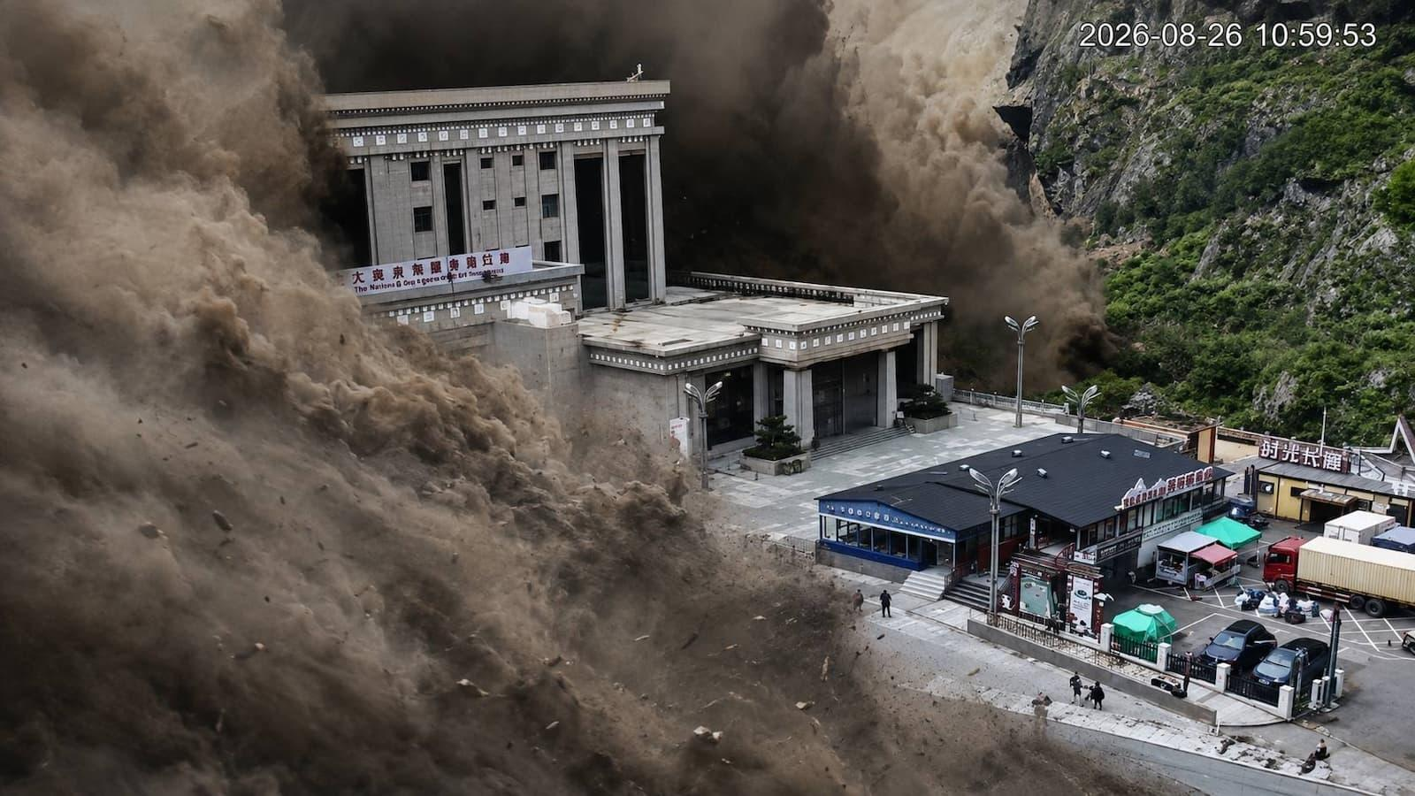
Nepal's monitoring architecture never had a window to issue a warning. Yet the deeper systemic failure is not merely that the alert arrived late—it is that the hazard itself was never clearly defined from the outset. In the immediate aftermath, seven different official agencies described the exact same physical event in seven entirely different ways.
This administrative confusion is far from cosmetic. How a state attributes a hazard directly determines what gets monitored, how infrastructure is engineered against it, and who holds the mandate to warn vulnerable populations. When hazard attribution is flawed, every subsequent downstream system—from hydrological sensors to building codes and emergency protocols—inherits that fundamental error.
This analysis examines how the Rasuwa disaster exposes this institutional disconnect across four core dimensions: the crisis of hazard taxonomy, the structural blindness of downstream-centric monitoring, the regulatory loopholes in infrastructure design codes, and the compounding vulnerabilities of linear asset corridors. It concludes with concrete, structural solutions designed to close the gap between hazard knowledge and operational risk management.
2. The 7.5-Minute Surge and the Administrative Babel
On the morning of 26 August 2026, a CCTV camera at the Chinese immigration office near Rasuwagadhi recorded the exact moment a debris-laden flood crossed the Nepal–China border. The event was triggered by a massive detachment of glacial ice and bedrock at an elevation of 5,200 metres on the northern flank of the Langtang Range. The mass descended over 2,000 metres down a near-vertical slope into the Lende River, propelling a highly destructive surge of water, sediment, and debris. Traveling at an estimated velocity of 150 km/h, the cascade reached the Rasuwagadhi border in roughly 7.5 minutes. Current consensus indicates the transient damming effect in the river was negligible; the mass essentially propagated straight through the corridor.
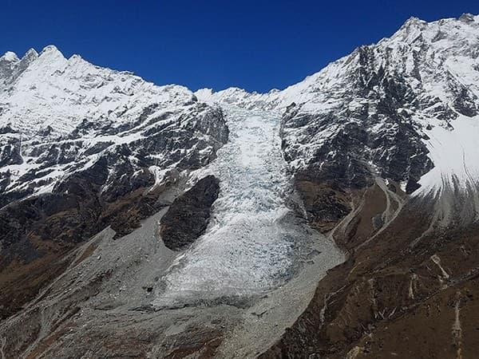
In the immediate aftermath, seven different agencies assigned seven distinct operational classifications to the exact same physical phenomenon. The United States Geological Survey (USGS) termed it a "Debris Avalanche and Flash Flood," separating the geological source from the downstream impact. Inside Nepal, the Department of Hydrology and Meteorology (DHM) classified it strictly as a riverine event—the "Bhotekoshi-Trishuli-Narayani Flood"—while the National Disaster Risk Reduction and Management Authority (NDRRMA) attributed it to a "Rock avalanche". Simultaneously, the Asian Disaster Preparedness Center (ADPC) applied a blanket multi-hazard designation encompassing an avalanche, glacial lake outburst flood (GLOF), landslide dam outburst flood (LDOF), and flash flood.
This divergence is not mere semantic untidiness; it is a diagnostic failure. How a state attributes a hazard dictates what physical parameters it monitors, what design standards it enforces, and which institutions hold the mandate to issue warnings. An agency that treats an event as a conventional flash flood will default to monitoring downstream river water levels. An agency that treats it as a GLOF will monitor established glacial lakes.
Rasuwa was neither. It was a non-linear, cryosphere-initiated cascade that involved no lake and reached populated infrastructure in minutes. Until Nepal establishes a formal legal and administrative category for this specific hazard profile, every subsequent system—from infrastructure engineering to early warning protocols—will continue inheriting the error of a miscategorized baseline.
3. The Failure of Downstream-Centric Monitoring
The misclassification of mountain hazards directly shapes where and how Nepal deploys its early warning systems (EWS). Because the state heavily weights its monitoring architecture toward conventional, rainfall-driven riverine floods, its sensors are stationed in lower-valley channels rather than high-altitude source zones.
The telemetry data from 26 August exposes the fatal flaw of this downstream-centric approach. The Department of Hydrology and Meteorology (DHM) operated monitoring infrastructure in the upper Bhote Koshi corridor, including a station at Shyaprubesi. At 08:40, that gauge recorded a water level of 1.62 metres—well below its 6-metre warning threshold—and stopped transmitting roughly ten minutes later as the debris surge destroyed it. Further downstream, the Betrawati station recorded 3.55 metres before going dark around 09:20. The system at the Rasuwagadhi border was washed away before it could transmit a single alert. The state's sensors did not fail to operate; they were simply situated in the impact zone rather than the source zone, rendering them blind to the hazard until it was already destroying them.
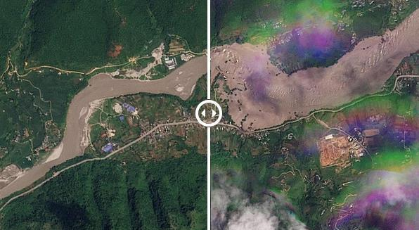
This architectural mismatch is not universal across Nepal, which makes the gap in mountain corridors even more striking. In the lower-gradient Karnali River Basin, Community-Based Flood Early Warning Systems (CBFEWS) are highly successful. Independent evaluations show the Karnali system provides 2 to 3 hours of actionable warning for downstream communities, generating a benefit-cost ratio between 24 and 73. But this technology succeeds specifically because its design matches the hazard: slow-onset, rainfall-driven flooding that can be tracked via upstream river gauges.
When applied to high-velocity, cryosphere-triggered cascades, this same river-gauge architecture consistently fails. A 2024 World Bank assessment explicitly identified this geographic vulnerability, noting that while Nepal’s EWS effectively tracks floods once they enter lower river systems, it cannot detect the high-mountain hazards—such as glacier collapses and landslide-dammed lakes—that initiate them. Recent history confirms this pattern. During the 2021 Melamchi disaster, formal upstream weather stations recorded precipitation, but no instrumentation detected the physical river-damming or its subsequent breach, resulting in zero formal lead time for the upper watershed. Similarly, the catastrophic 2012 Seti River rock-ice avalanche and the 2024 Thame cascading GLOF bypassed formal monitoring entirely; neither had sensors tracking the high-altitude source zones.
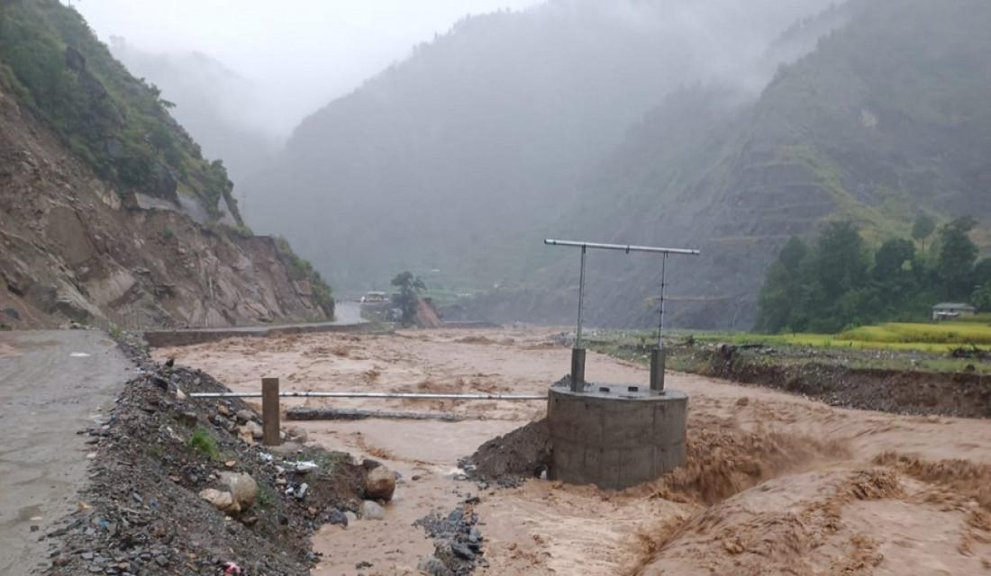
The alternative is active source-zone monitoring, demonstrated sharply by the May 2025 Blatten disaster in Switzerland. Because the Birch Glacier was recognized as a structural hazard, Swiss authorities deployed slope radar, GPS, and cameras directly on the ice mass. By tracking accelerating glacier deformation, authorities interpreted the signals and evacuated over 300 residents from the Lonza valley nine days before roughly 20 million tonnes of rock and ice collapsed. The resulting death toll was one—a resident who unwittingly bypassed the evacuation cordon.
The distance between Blatten’s outcome and Rasuwa’s devastation was not a difference in the magnitude of the hazard. It was a difference in spatial placement. By waiting for a mountain hazard to become a river flood, Nepal’s current monitoring framework guarantees that warning times for cascading extreme events will always be measured in minutes, if they are issued at all.
4. The Regulatory Blindspot in Infrastructure Design
The disconnect between high-altitude hazard realities and ground-level execution is most evident in Nepal’s engineering standards. The Guidelines for Study of Hydropower Projects (2018) and the Powerhouse Design Guidelines (2018) govern how critical energy infrastructure is planned, sited, and built across the country's river corridors. These documents establish rigorous technical criteria, including capacity-differentiated flood sizing—ranging from 1-in-50-year return periods for projects under 10 MW up to 1-in-200-year return periods for projects exceeding 100 MW—alongside strict elevation safety thresholds for powerhouses.
Yet a critical regulatory loophole persists within these frameworks. For large Run-of-River (RoR) projects, which dominate Nepal's energy matrix, the assessment of glacial lake outburst floods (GLOFs) and extreme mountain hazards is frequently treated as an advisory study requirement or a non-binding recommendation rather than an absolute engineering mandate. Under Section 1.1.3.2 of the Powerhouse Design Guidelines, incorporating early warning systems and evaluating GLOF potential for projects over 100 MW is formally "recommended" rather than legally enforced. Mandatory EWS planning is strictly codified primarily for storage-type schemes (Format C2), leaving the vast majority of high-head RoR facilities legally permitted to bypass real-time warning integration.
This creates a dangerous mismatch between design assumptions and physical realities. Traditional flood-sizing standards calculate discharge based on historical rainfall and standard river-channel hydrology. They are mathematically unequipped to model a non-linear, multi-hazard cascade—such as an ice-rock avalanche dropping 2,000 metres at 150 km/h—that introduces massive volumetric surges of bedrock, ice, and sediment into a restricted river gorge.
When the 26 August event struck the Trishuli corridor, it did not target a single isolated facility; it propagated sequentially through a dense chain of operational and under-construction assets. Facilities like the 111 MW Rasuwagadhi project, the Chilime plant, and the 216 MW Upper Trishuli-1 site suffered simultaneous structural failures or severe inundation.
Comparing this with regional frameworks reveals both the limits and necessity of regulatory reform. India’s Central Electricity Authority (CEA) has advanced toward operationalized GLOF risk integration, issuing revised standard operating procedures that mandate multi-hazard assessments and cloud-based telemetry for vulnerable hydroelectric projects. Yet, as demonstrated by the 2023 South Lhonak disaster in Sikkim—where a major GLOF bypassed emerging institutional safeguards and destroyed the Teesta III dam—regulatory checklists alone fail if they treat cascading cryospheric hazards as low-probability anomalies rather than structural certainties.
In Nepal, the 2018 guidelines reflect a system that still plans for rivers as water, failing to account for them as active transport vectors for massive geological mass-wasting. Until statutory design codes mandate compounding-hazard modeling and binding EWS integration for all corridor-level projects regardless of scheme type, developers will continue building state-of-the-art powerhouses inside unacknowledged hazard zones.
5. Corridor-Level Vulnerability along the Trishuli River
The destruction unleashed on 26 August 2026 extended far beyond individual energy assets, exposing the systemic vulnerability of linear infrastructure networks in high-mountain corridors. The disaster demonstrated that critical physical assets—roads, bridges, and public facilities—do not merely suffer passive damage during extreme cascades; they can become active physical vectors that amplify downstream destruction.
Along the Bhote Koshi–Trishuli corridor, preliminary post-disaster assessments underscored this risk exposure. The Ministry of Infrastructure Development reported that approximately 40 kilometres of roadway and 41 bridges were completely destroyed in Rasuwa alone, severing primary trade and rescue routes through the Betrawati–Mailung–Syafrubesi–Rasuwagadhi axis. Copernicus Emergency Management Service (EMS) mapping revealed that structural devastation extended across entire built-up zones rather than narrow river margins, identifying over 860 mapped buildings across Timure and Syapru Besi as damaged or destroyed.
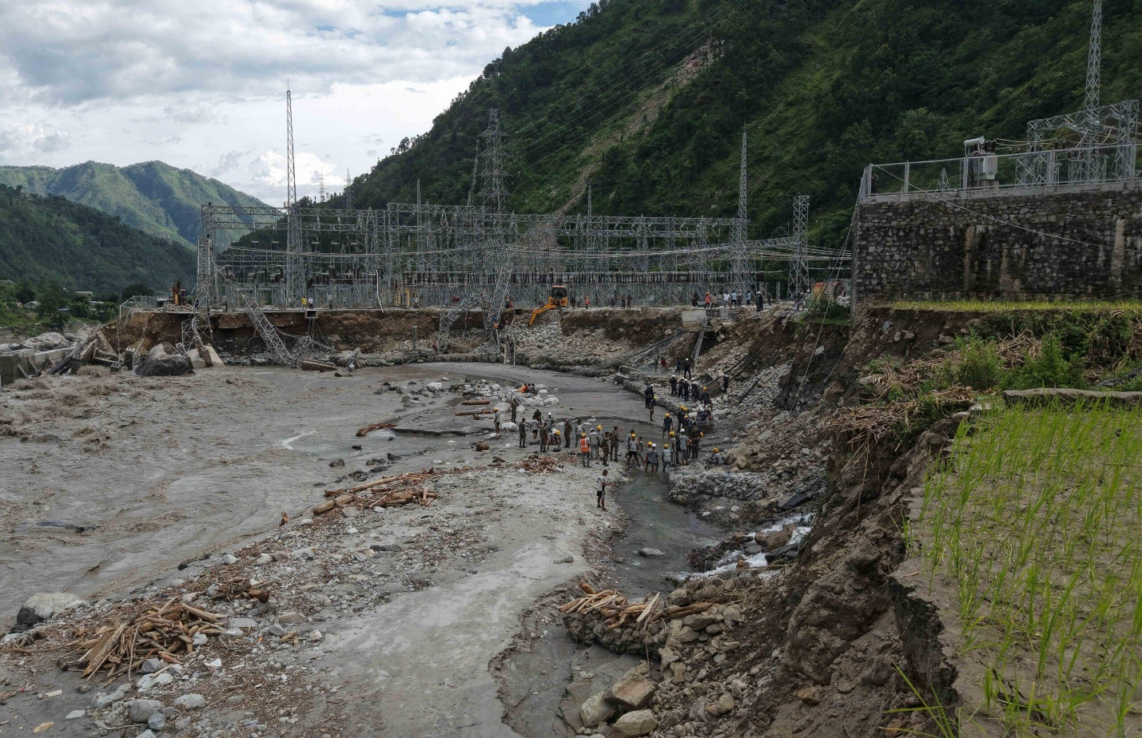
This spatial footprint highlights a critical flaw in high-mountain spatial planning: traditional setback distance from the ordinary river channel is an inadequate proxy for exposure during low-frequency, high-consequence cascading events. When an extreme surge carrying massive volumes of rock, ice, and sediment enters a restricted gorge, the effective hazard footprint expands laterally, engulfing settlements and infrastructure previously assumed safe.
Furthermore, bridge infrastructure revealed a compounding structural risk. In a high-velocity debris flow, the failure of an upstream bridge does more than sever connectivity; the shattered deck, steel structural members, and accumulated wreckage are swept downstream, transforming the infrastructure itself into heavy, battering-ram debris that increases the impact load on subsequent bridges and downstream powerhouses.
This cascading collapse also compromised vital social and emergency infrastructure. World Health Organization (WHO) preliminary assessments recorded three health posts fully destroyed and one hospital partially damaged, compounding a scenario where 62 severely injured individuals required emergency evacuation across a fractured transport network. Similarly, the Ministry of Education reported 20 damaged schools across Rasuwa, Nuwakot, and Dhading, while strategic public nodes—including the Rasuwagadhi customs facility and three local police posts—were wiped out. The destruction of these facilities stripped the impact zone of its institutional coordination capacity precisely when emergency response was most required, proving that corridor resilience depends as much on the functional network integrity of emergency structures as it does on the structural survival of individual dams.
6. Solutions — A Re-engineered Risk Framework
Preventing future corridor-level catastrophes requires abandoning the fiction that high-mountain disasters are unpreventable acts of nature. Nepal’s institutional frameworks must transition from reactive disaster management to proactive, system-wide risk engineering. This shift requires targeted structural and regulatory interventions across three core pillars:
- Codify Cascading Cryospheric Hazards:
  - The National Disaster Risk Reduction and Management Authority (NDRRMA), the Department of Hydrology and Meteorology (DHM), and the Department of Electricity Development (DoED) must establish a unified legal and administrative classification for non-linear, cryosphere-triggered cascades.
  - Standardizing this taxonomy eliminates inter-agency confusion, ensuring that every government body operates from the same hazard baseline when designing infrastructure or issuing alerts.
- Deploy Space-Ground Layered Surveillance:
  - Monitoring infrastructure must move out of lower-valley riverbeds and into high-altitude source zones above 4,000 metres.
  - Integrating satellite-based InSAR, slope-deformation radar, and automated ice-mass sensors—similar to proven alpine monitoring protocols in Switzerland—provides the critical lead time needed to issue actionable evacuations before a surge enters populated corridors.
- Reform Hydropower Licensing and Corridor Planning:
  - DoED must amend the 2018 Hydropower and Powerhouse Design Guidelines to make GLOF and multi-hazard assessment mandatory for all major river-corridor projects, regardless of scheme type.
  - Siting approvals must evaluate cumulative, multi-project vulnerabilities rather than examining individual facilities in isolation, ensuring that structural resilience is built into every link of the energy network.
By aligning legal definitions, upgrading surveillance architectures, and enforcing rigorous corridor-wide engineering standards, Nepal can transform its approach to mountain risk—ensuring that future infrastructure developments are engineered to withstand the changing realities of the Hindu Kush Himalaya.
